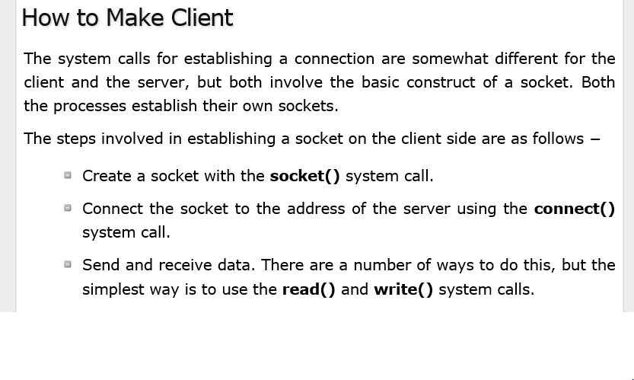

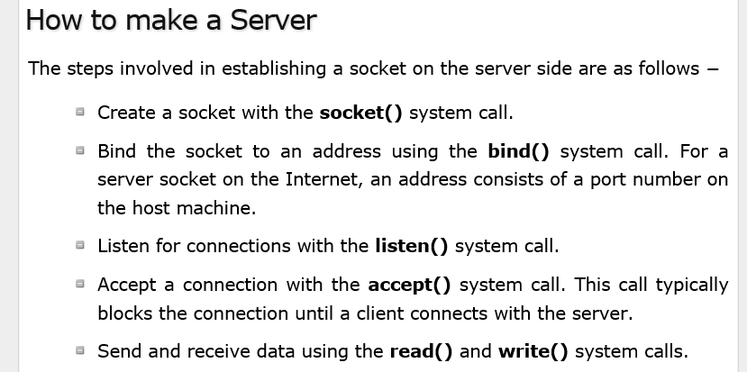

<https://www.tutorialspoint.com/unix_sockets/client_server_model.htm>

<https://www.tutorialspoint.com/unix_sockets/socket_structures.htm>